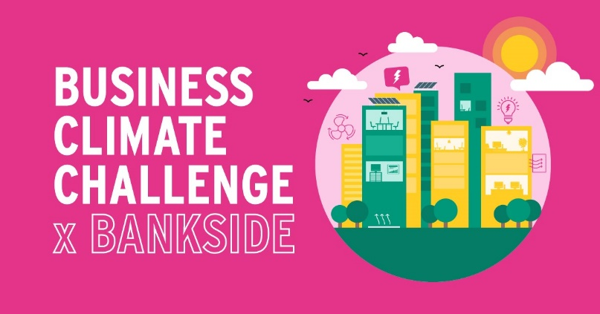
Expression of Interest form
Business name
Sector
Registered Charity | ☐ Yes ☐ No
Number of employees
Does your business own or lease your building | ☐Own ☐Lease ☐Other
Are you able to nominate a decision maker who can approve changes to or investments in the building? | ☒ Yes ☐ No
Business Details

Building Details
Building address
Approx size (gross internal area) Sq.M
Number of workspaces
If leasing your building, please specify:
- Lease duration
- Lease type
How long has your business been in this building?
How long does your business plan to be in this building?
Occupancy model (single or multiple)
Does your building, or the part of the building you occupy have a building management system (BMS) | ☐ Yes ☐ No ☐ Unsure
Have any energy improvement or retrofit works been completed on your building? | ☐ Yes ☐ No ☐ Unsure Year:
Have you completed any energy improvements or retrofit works on your building?
Building type (i.e. office space, industrial, retail, hospitality, mixed use, other)

Do you have access to your energy data?
☐ Yes ☐ No ☐ Unsure
Why is your business interested in participating in this Business Climate Challenge now? (tick all that apply)
☐ Potential cost savings
☐ Improving the quality of services in the building
☐ Reducing energy usage
☐ Enhanced property value
☐ Environmental goals of the business
Other reasons: [Please type]
Has your business made any formal environmental commitments?
☐ Emission reduction commitments
☐ Environmental pledges (Race to Zero, other).
☐ Climate Change Strategy
Other commitments: [Please type]
Please return this form to the Better Bankside contacts below by Friday 12 March 2021:
Amandeep Kellay ak@betterbankside.co.uk
Josephine Clarke jc@betterbankside.co.uk

